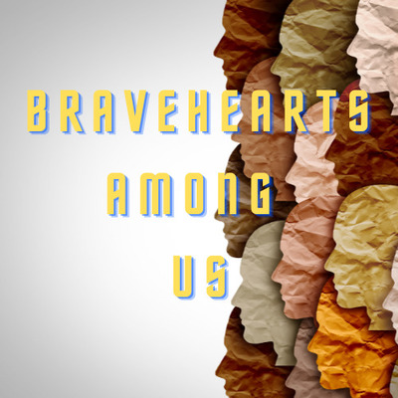

ABOUT THE PROJECT
Among the many global problems and turmoil in the world, all living things and nature need to be safe, hope for the future, and joy of life more than ever before. Here, the presence of many secret heroes whose names even we do not know supports us at all times and under all circumstances with love and devotion gives us peace of mind.
Younger generations need good examples from which they can be inspired. Students will gain insight into the best examples of goodness and sacrifice, the people who live among us, whom we all admire, who are the true heroes of our time with their work and dedication, and their life stories, goals, and work.
Students will learn how to be more responsible, discover values ​​and strengths that are appreciated in different cultures, and create many collaborative works inspired by heroes who have solved global problems and fought.
In this project, students will prepare a monthly interactive magazine with various Web 2.0 applications.

AIMS
The purpose of our project is to raise awareness about the sacrifices made by these devoted people among us for our world and all living things, and their fascinating stories.
Through this project, pupils from different countries will not only improve their language skills (English) but will also develop various skills and competencies such as teamwork, decision making, communication, leadership, digital literacies and collaborative working,
Our students will have the opportunity to use their knowledge of English and gain experience in group partnerships,
Students who share their knowledge will develop their ICT skills,
They'll have the opportunity to develop practical English language with their peers peacefully,
They'll get the chance to make friends from all over the world with their practical English and get to know different cultures,
Raise students' awareness of the importance of inspirational people in the society who contribute to the well-being and safety of others,

WORK PROCESS

*Our project will start in February and will be completed at the end of May.
*Routine warm-up activities will be done when the project starts. These are avatars, parent permission documents, meetups, determination of mixed country teams and logo design competitions etc..
*An interactive magazine will be prepared by creating joint and collaborative works within the framework of the theme determined with the partners every month. ...
*Each partner, together with a group of mixed team students, will contribute to the special section of the journal by discussing it harmoniously and collaboratively in the Forum within the specified time. In mixed teams, students will prepare different activities such as collaborative and joint studies with their mentors in different sections of the magazine; Comics, Interview, Fun pages etc.
*The pace of the work and the enrichment of the activities will be determined in the meetings held with the partners.

EXPECTED RESULTS
The students are expected to improve their English Language learning skills, ICT skills and communication skills.
Students will learn how to be more responsible, discover values ​​and strengths that are appreciated in different cultures, and create many collaborative works inspired by heroes who have solved global problems and fought.
Foreign partners are expected to join in the project, therefore both teachers, students and parents will experience the joy and excitement of internationalism and multiculturalism. The project will have a cultivated and colourful process that will be rich in engagement, motivation, joy, collaboration, cooperation and creative ideas.

OUR WORKS
Our city ‘’İSTANBUL’’ promotional video
https://youtu.be/Ol5IzTLMdwo
Our country ‘’TURKEY’’promotional video
https://youtu.be/lPFXs_eG_wE
DOCTORS’ MAGAZINE STORY SECTION E- BOOK /DOKTORLAR DERGİSİ HİKAYE BÖLÜMÜ ELEKTRONİK KİTAP
https://viewer.joomag.com/team-1-story-section-dosyasının-kopyası/0416542001648238483
POLICE OFFICERS’ MAGAZINE PIONEERS SECTION E-B00K /POLİS MEMURLARI DERGİSİ ÖNDERLER BÖLÜMÜ ELEKTRONİK KİTAP
https://online.fliphtml5.com/swqju/cuhb/
MEETINGS WITH PROJECT PARTNERS/STUDENTS/PROJE ORTAKLARIMIZLA /ÖĞRENCİLERLE TOPLANTILARIMIZ
